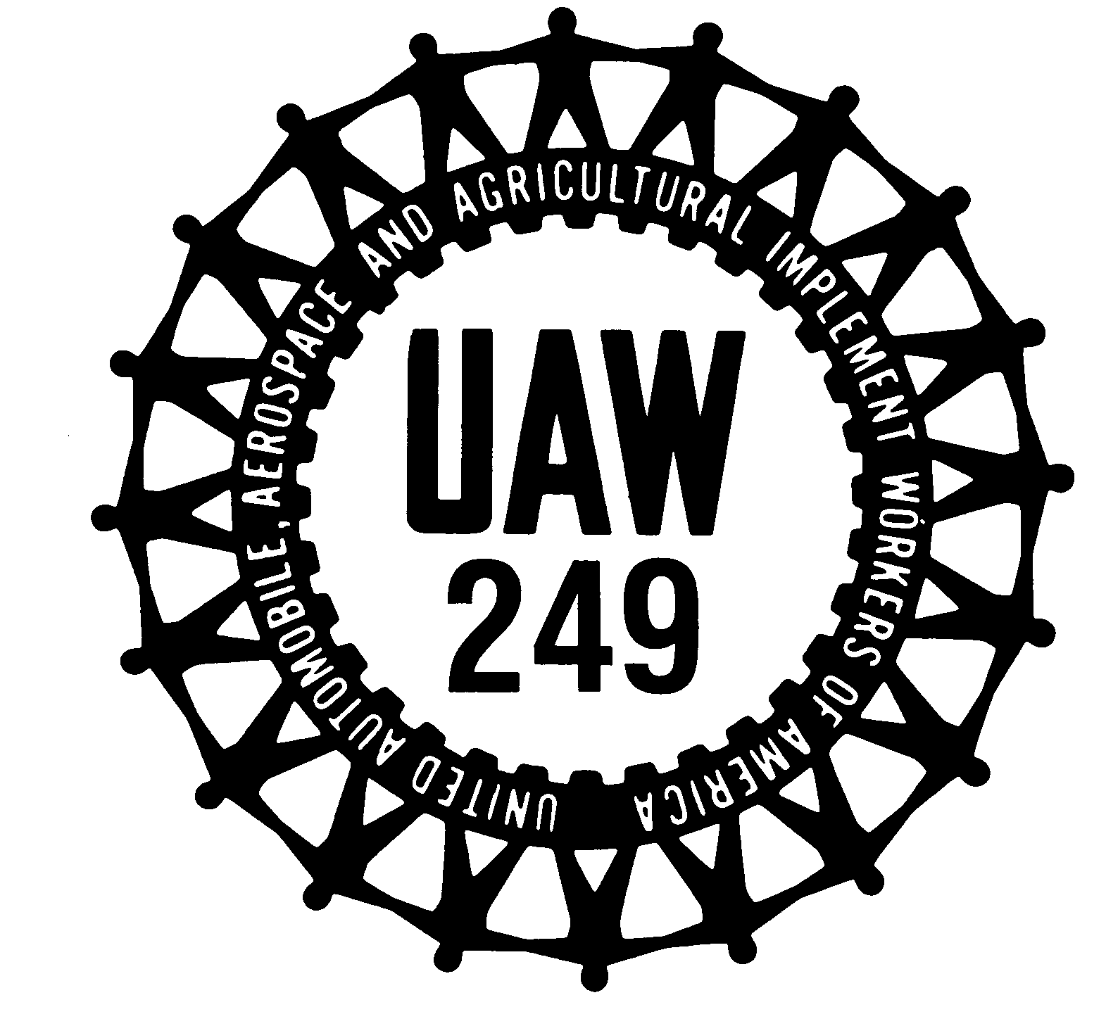

Notice of Nominations
Amalgamated Local 249 Union UAW

The following members of Amalgamated Local 249 have been nominated for the respective offices listed below for the election beginning at 5:00 a.m. on Thursday, May 7, 2020 and will close at 5:00 a.m. Friday, May 8, 2020 and beginning at 5:00 a.m. on Saturday, May 9, 2020 and will close at 5:00 a.m. on Sunday, May 10, 2020 (24 continuous hours each day) Election will be held at UAW Local 249, 8040 NE 69 Hwy, Pleasant Valley, MO. Acceptance of nomination must be on a properly completed form available at the Local Union Hall. Acceptance of nomination must be deposited in the ballot box at the Local Union Hall no later than 4:00 p.m. on Friday, March 20, 2020.

President
Jason Starr
Wins by acclamation

Vice President
Neal Byers
Tony Renfro

Recording Secretary
Shirley A. Mata
Wins by acclamation

Financial Secretary
Dana Davidson
Wins by acclamation

Treasurer
Chrissy Kline
Wins by acclamation

Trustees
Jay Bosler
Jeremy Fue
Stephanie Shines
Connie Thomas
Sade J. Ott
Ed Scaggs

Sergeant-At-Arms
Leon “Big Daddy” Allen
Wins by acclamation

Guide
Naoyanna Andrews
Gary Thomas
Nathan “Red” Himes

Bargaining Chairperson for Assembly Unit
Jim Fisher
Wins by acclamation

Bargaining Committee Members of the Assembly Unit

Don Picard
Dean Freed
Steve Chorbak
Won by acclamation

Skilled Trades Bargaining Committee Member

Michael S. Payne
Ron Pangborn
L. Scott Pyle

Bargaining Chair for Nurses
Cathy Koogler
Wins by acclamation

Retired Member
John Lowe
Wins by acclamation
Skilled Trades, Maintenance Clerks #1 Shift and E Crew and Stamping Operations and MP&L - #1 Shift
Committeeperson

John Herrick
Mark Anderson

Alternate Committeeperson

Ryan Farrell
Andy Crawford
Matt Callahan

Skilled Trades and Maintenance Clerks, #2 shift Committeeperson

Tim Rueckert
Wins by acclamation

Alternate Committeeperson

Shane Troncin
Wins by acclamation

Skilled Trades and Maintenance Clerks #3 Shift and D Crew
Committeeperson

Jose L Olivencia
Wins by acclamation

Alternate Committeeperson

MP&L (A Crew Truck, #2 Shift Transit) Committeeperson

Ben Pate
Andrew Yoakum

Alternate Committeeperson

Steven (Kyle) Mansell
Wins by acclamation

MP&L (B Crew Truck, #3 Shift Transit) Committeeperson

Michael Dean Wheeldon
Wins by acclamation

Alternate Committeeperson
Jerrod Ballard
Wins by acclamation

Stamping Operations and Stamping MP&L & Transit Paint - #2 Shift
Committeeperson

Rob Brusick
Derrick Dugan

Alternate Committeeperson
Michael J. Minor
Wins by acclamation

Stamping Operations and Stamping MP&L & Transit Paint - #3 Shift
Committeeperson

Robin S. Taylor
Kenny Seeley
Rick Mandl (Papa Smurf)

Alternate Committeeperson

Matt Robinson
William Decoudres

Transit Body (2300) and Inspectors (0150) - #2 Shift
Committeeperson

Dave Orr
Wins by acclamation

Alternate Committeeperson

Brian Ranes
Wins by acclamation

Transit Body (2300) and Inspectors (0150) - #3 Shift
Committeeperson

John Williams
Troy Lyman

Alternate Committeeperson

Anthony A. Crawford
Wins by acclamation

Transit Trim Loop Line 1 & 2 (2500), Transit Chassis Zones 1 & 2 (2800) - #2 Shift Committeeperson

Jeremy Mallinson
Wins by acclamation

Alternate Committeeperson

Courtney Anchors
Wins by acclamation

Transit Trim Loop Line 1 & 2 (2500), Transit Chassis Zones 1 & 2 (2800) - #3 Shift Committeeperson

Patrick West
Wins by acclamation

Alternate Committeeperson

Jacob D. Diggs
Wins by acclamation
Transit Trim (2500) Lines 3, 4, 4a, 5, 6, 7, 8, 9 and IP Line - #2 Shift
Committeeperson

David Russell
Wins by acclamation

Alternate Committeeperson

Michael Hanner
Wins by acclamation

Transit Trim (2500) Lines 3, 4, 4a, 5, 6, 7, 8, 9 and IP Line - #3 Shift
Committeeperson

Zach Lane
Wins by acclamation

Alternate Committeeperson

Robert L. Welker III
Josh Curtis
Clevon Jones

Transit Chassis Zones 3, 4 & 5 (2800), MSC Building, Torque Inspectors, QOSC & SPC - #2 Shift
Committeeperson

Clayton Tryon
Richard Gillette
Shane Freeman

Alternate

Amber Virley
Zachery Jacob Pridgen

Transit Chassis Zones 3, 4 & 5 (2800), MSC Building, Torque Inspectors, QOSC & SPC - #3 Shift
Committeeperson

Scott Peterson
Wins by acclamation

Alternate Committeeperson

Alissa Foit
David Wood

Transit Dept 85 (2850) - #2 Shift, Truck Dept 86 - A Crew (1860) and Truck Paint - A Crew (1410)
Committeeperson

Bret “Chicken” Zorich
Wins by acclamation

Alternate Committeeperson
Irene Rivera Rule
Wins by acclamation

Transit Dept 85 (2850) - #3 Shift, Truck Dept 86 - B Crew (1860) and Truck Paint - B Crew (1410)
Committeeperson

Ben Brown
Wins by acclamation

Alternate Committeeperson

Jeff Mathews
Wins by acclamation

Truck Body Shop (1310) and Inspectors (0154) – A Crew
Committeeperson

Bob Hough
Wins by acclamation

Alternate Committeeperson

Truck Body Shop (1310) and Inspectors (0154) - B Crew
Committeeperson

Mike Clark
Wins by acclamation

Alternate Committeeperson

“G”
Robin Bindel

Truck Body Shop (1310) and Inspectors (0154) and Truck Trim Zones 1-3 - C Crew
Committeeperson

Gary Conkling
Roby Davenport

Alternate Committeeperson

Charles Allen
Thomas Low

Truck Chassis Zones 3-5, (1810) L-12 Chassis Repair, Repair Hole, Roll Test, Quality Office, Torque Inspectors and Inspectors & Truck MSC - A Crew Committeeperson

Rick Moreland
Wins by acclamation

Alternate Committeeperson

Michael A. Quick
Wins by acclamation

Truck Chassis Zones 3-5, (1810) L-12 Chassis Repair, Repair Hole, Roll Test, Quality Office, Torque Inspectors and Inspectors & Truck MSC - B Crew Committeeperson

Justin Chapman
Wins by acclamation

Alternate Committeeperson

Jerry V. Carroll
Wins by acclamation

Truck Chassis (1810) L-12 Chassis Repair, Repair Hole, Roll Test, Quality Office, Torque Inspectors and Inspectors & Truck MSC - C Crew
Committeeperson

Leon “Big Daddy” Allen
Wins by acclamation

Alternate Committeeperson

Pat Baird
Enrique (Punisher) Trillo

Truck Trim (1510) Zones 1-4, SPC, QOSC and Truck Paint E-Coat - A Crew Committeeperson

A.J. Stockton
Wins by acclamation

Alternate Committeeperson

Deron Mebane
Adam Cockrum
Truck Trim (1510) Zones 1-4, SPC, QOSC and Truck Paint E-Coat - B Crew Committeeperson

Devin Foster
Wins by acclamation

Alternate Committeeperson

Wymann Simpson
Wins by acclamation

Truck Trim (1510) Zones 5-6, Truck Chassis (1810) Zones 1-2 and L-12 Trim Repair - A Crew
Committeeperson

Tino Scalicy
Danny Johnson (Hightower)

Alternate Committeeperson

Richard L White
Blake Davis
Donald Nye

Truck Trim (1510) Zones 5-6, Truck Chassis (1810) Zones 1-2 and L-12 Trim Repair - B Crew
Committeeperson

Mark Phalp
Steffon Sprott
Sparkle Wilson

Alternate Committeeperson

Rob Crismon
Wins by acclamation

Truck Trim (1510) Zone 6, Trim Repair. L12 Repair, Dept 86 & MP&L - C Crew Committeeperson

John Travers
Wins by acclamation

Alternate Committeeperson

Adam Sanders
Wins by acclamation

Truck Paint & E-Coat (1410)/QOSC/Torque Inspectors/ Quality Dept, SPC & Truck Trim Zones 4-5 – C Crew
Committeeperson

Kevin Kincheloe
Wins by acclamation

Alternate Committeeperson

Terri L. Hall
Jeffrey Honts
Amanda Shoff

Slp/cim//opeiu277

