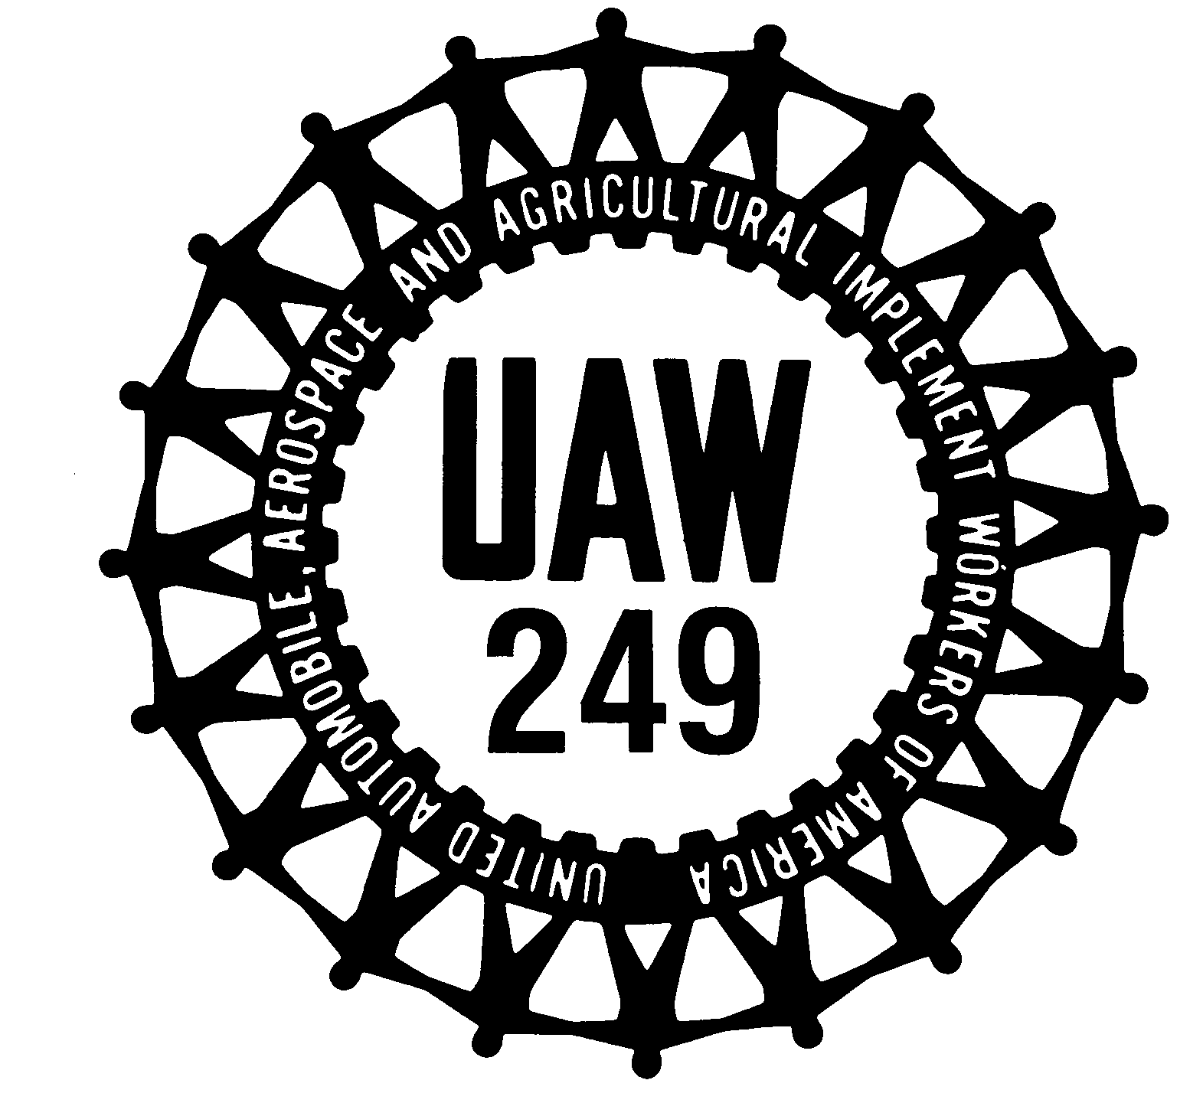
UAW Local 249 Bulletin

KANSAS CITY ASSEMBLY PLANT EMPLOYEES TEMPORARY LAYOFF (TLO)

These are obviously trying and stressful times and your local leadership recognizes the difficulties we are facing together. We along with your International staff have been working tirelessly to come up with solutions that will best protect the health of our members, our families and our communities. Nothing is more important than the safety of our membership. We are striving to do everything within our power to protect your health and safety on the job from the effects of this crisis but also from potential long-term impacts on all of us socially and economically.

This is a very fluid situation and details are changing hour to hour and day to day. We urge you to stay up to date with the events taking place at UAW Local 249 and the Kansas City Assembly Plant. You can do this by viewing the UAW Local 249 Facebook page, website (local249.org) App and on the Local 249 Hotline at 1-844-371-1519. The following is a list of the modified production schedules for both Transit and Trucks Systems as of March 18, 2020. These are subject to modification and the company will notify all members as required.

TRANSIT SYSTEM MODIFIED PRODUCTION SCHEDULES

Production will run as scheduled thru the end of night shift on Thursday, March 19th. On Friday March 20, 2020 No Production employees will be working.

Week of March 23rd

The Transit System will be on a scheduled down week. No Production employees are to report to work unless notified by supervisor or robo call.

Week of March 30th

Days Shift will only be on a 4x10 schedule. Stamping Press Line #1 & #2 Shift on a 5x8 schedule/Sub Assembly #2 Shift will be working. Night Shift will be on a Down Week. Stamping Press Line #3 & Sub Assembly #3 Shift will be on a Down Week

Week of April 6th

Day Shift will only be on a 4x10 schedule. Stamping Press Line #1 & #2 Shift on a 5x8 schedule/Sub Assembly #2 Shift will be working. Night Shift will be on a Down Week. Stamping Press Line #3 & Sub Assembly #3 Shift will be on a Down Week.

Week of April 13th

Day Shift will be on a Down Week. Stamping Press Line #2 Shift will be on a Down Week. Night Shift only will be on a 4 x 10 Schedule. Stamping Press Line #1 & #3 Shift will be working on a 5x8 hour schedule/Sub Assembly #3 will be working

Week of April 20th

Day Shift will be on a Down Week. Stamping Press Line #2 Shift will be on a Down Week. Night Shift only will be on a 4 x 10 Schedule. Stamping Press Line #1 & #3 Shift will be working on a 5x8 hour schedule/Sub Assembly #3 will be working.

TRUCK SYSTEM MODIFIED PRODUCTION SCHEDULES

Production will run as scheduled until the end of the night shift on Thursday, March 19th. On Friday No Production employees will be working with the exception of B Crew Pre-Delivery (report to work on Friday night) and C-Crew Pre-Delivery (will report to work for Friday (Day Shift), Saturday (Day Shift), and Sunday (Night Shift).

For the week of March 23rd the Truck System will be on a scheduled down week. No Production employees are to report to work unless notified by supervisor or robo call.

For the week of March 30th - A Crew and B Crew will work a Monday thru Thursday Schedule. For C Crew it will be a Down Week.

For the Week of April 6th - A Crew and B Crew will work a Monday thru Thursday Schedule. For C Crew it will be a Down Week.

Truck Schedule for the week of April 13th and beyond has not been determined.

UNEMPLOYMENT INFORMATION

You will still need to file your weekly request for payment. A benefit week runs from Sunday through Saturday. A weekly request for payment can be filed beginning Sunday after the week has ended.

All TPT employees will also be on layoff during this time. TPT employees are not eligible for SUB pay benefits but may be eligible to receive State unemployment benefits. Follow the instructions below to file your claim.

Claiming unemployment is a two-step process. Ford is taking care of the first step to begin the claim. You will still need to file for your weekly benefits after your claim has been activated. The claim week runs from Sunday through Saturday. The week must be claimed after the Saturday week ending date. Weekly claims can only be filed on the Internet at www.labor.mo.gov. To claim unemployment, it must be submitted on the following dates:

If you do any work during the week, you must report the gross amount of any wages on your claim for the week. It is very important that all wages be reported accurately on weekly claims. Wages are to be reported during the week in which the work is performed. This include wages from other work performed during the week you are claiming.

If you are paid vacation pay, holiday pay, or paid time off for any days during a week you are requesting, report the gross amount.

We strongly suggest you register with Missouri State Unemployment website to track your unemployment in case problems arise. Remember, you will not receive SUB pay until your receive unemployment (or letter of denial) because unemployment generates SUB pay. This is a 2-3 week process to receive SUB pay.

We would like to thank the membership for your continued patience during very stressful times and also thank our Team Solutions and Skilled Trades members for all your hard work and dedication in providing our membership with the necessary resources needed to sustain us during this difficult process. We urge all members to continue to follow the guidelines provided by the Center for Disease Control (CDC) and local and state authorities.

Jim Fisher Jason Starr
Bargaining Chair President
Bargaining Committee

Steve Chorbak Dean Freed Don Picard Ron Pangborn
slp/opeiu277

